**DSA Assignment**

**19 June, 2025**

**Name – Hemang Joshi**

**Roll no. -23/11/EE/042**

**LeetCode Id – Guy-In-Myths**

**GeekforGeeks - inhuman**

**Github Repo Link - Inhuman-Jester/Job-Hunt**

1. Find the Town Judge

○ Platform: LeetCode

○ Link: https://leetcode.com/problems/find-the-town-judge/

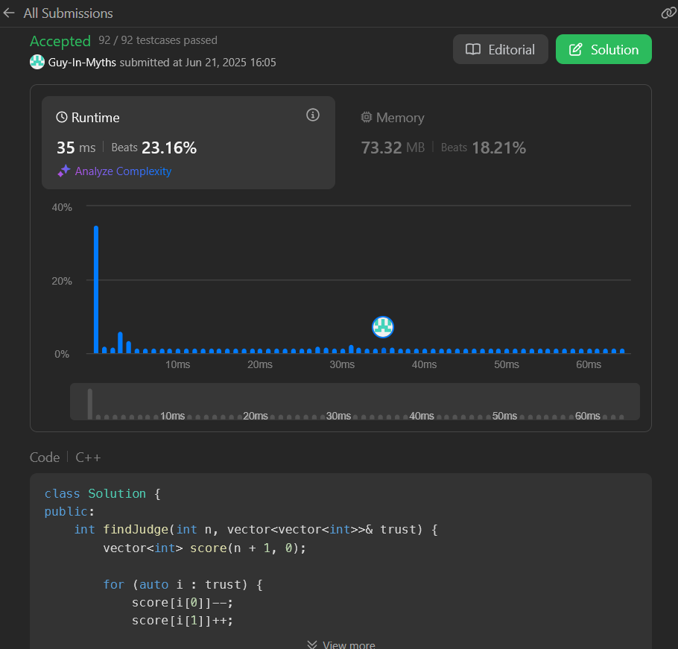

Question 2. Plus One

○ Platform: LeetCode

○ Link: https://leetcode.com/problems/plus-one/description/

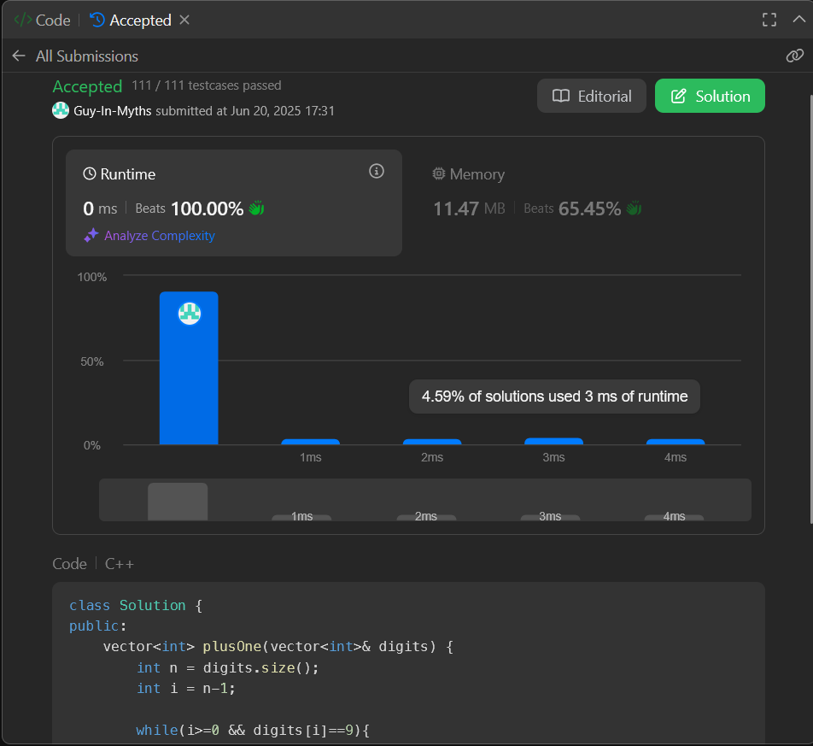

3. Maximum Subarray

○ Platform: LeetCode

○ Link: https://leetcode.com/problems/maximum-subarray/description//

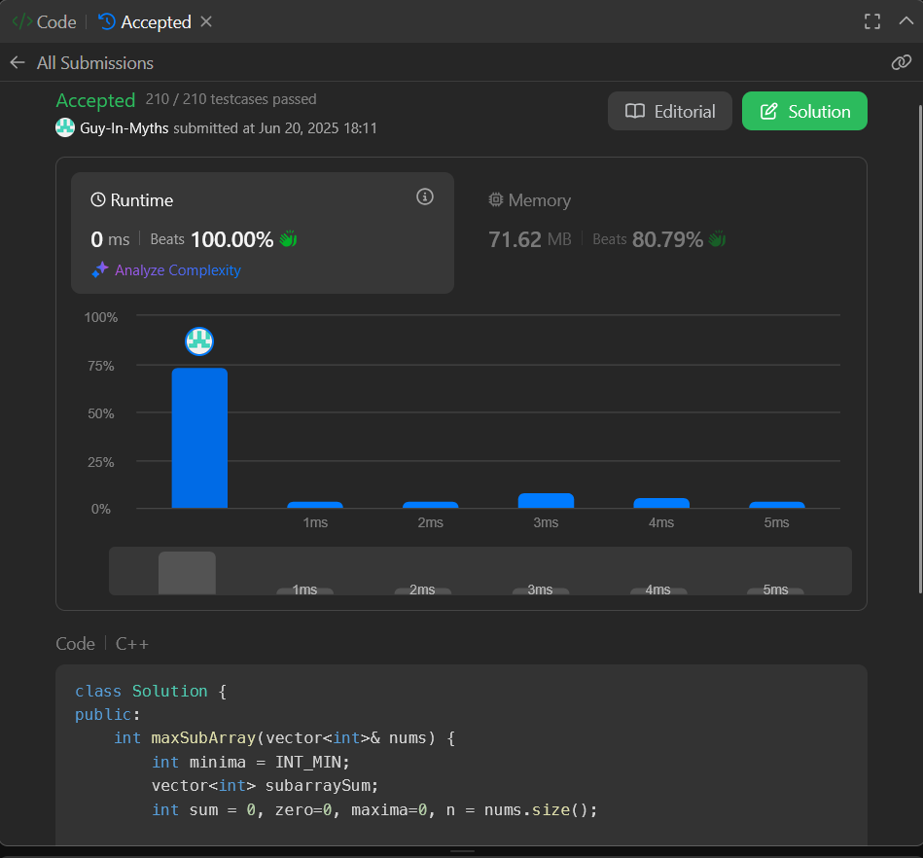

4. Assign Cookies

○ Platform: LeetCode

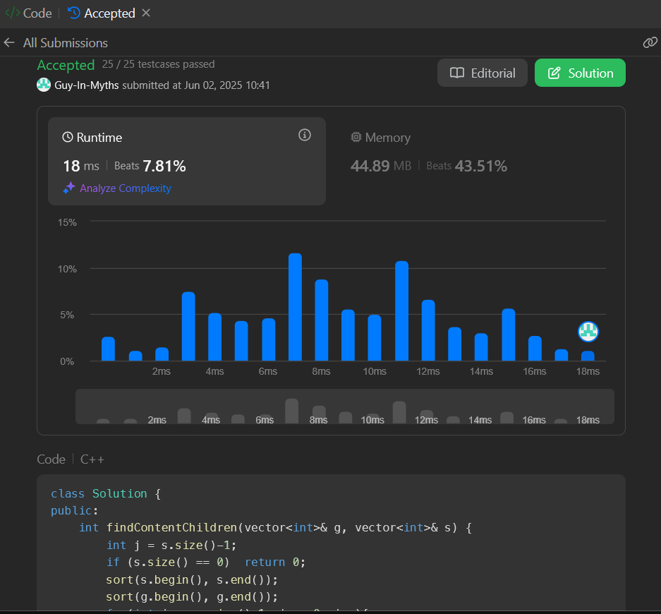○ Link: https://leetcode.com/problems/assign-cookies/description/